Community Food Wastage Reduction Portal
Design Document

Version 1.0



Group Id: S26PROJECT51921 (BC220408429)
Supervisor Name : Dr. Hasnain Ahmed

Revision History
Date (dd/mm/yyyy) | Version | Description | Author
Current date | 1.0 | Introduction of the project | Write student(s) id

Table of Contents

- Introduction of Design Document
- Entity Relationship Diagram (ERD)
- Sequence Diagrams
- Architecture Design Diagram
- Class Diagram
- Database Design
- Interface Design
- Test Cases

1. Introduction of Design Document
This design document is a detailed plan for the Community Food Wastage Reduction Portal. In the SRS, we already wrote what the system should do. In this document, we will plan how the system will work — its structure, data, screens, and main user flows.
Our portal will connect food donors (restaurants, hotels, individuals) with people who need food (NGOs, shelters) and volunteers who can help with pickup. Donors will post extra food, receivers will search and claim it, and admin will check users and listings to keep things safe. This document helps us organize all of that before we start coding.
This document is for our project team, supervisor, and anyone who wants to understand the system layout. We will not repeat the full SRS here, but each design section will link back to the requirements so we do not miss anything important.
1.1 Contents of This Document
Our design document has 8 sections:
# | Section | What we will include
1 | Introduction of Design Document | Why we need this document, what it contains, and why the design phase is important for our project.
2 | Entity Relationship Diagram (ERD) | A diagram showing main data items (User, Donation, Claim, Notification, etc.) and how they connect to each other.
3 | Sequence Diagrams | Step-by-step flow showing what happens when a donor posts food, an NGO claims it, or pickup status is updated.
4 | Architecture Design Diagram | A simple picture of how the system is split — user screens, main application logic, database, and any outside services like maps.
5 | Class Diagram | Main parts of the system (classes) and what information and actions each part will handle.
6 | Database Design | Tables we will create, field names, and how records link together.
7 | Interface Design | Wireframes and layout plan for important screens — login, dashboards, post food, browse food, claim food, and admin pages.
8 | Test Cases | Test cases to check if main features work as planned after development.
These sections together form our full design plan — from how data is stored to how users will see and use the portal.
1.2 Purpose of the Design Phase in Software Development
The design phase comes after the SRS and before development. In this phase, we plan the system in detail so we know what to build and how pieces fit together.
Why the design phase matters:
- Clear direction
Before coding, we should know how donor posting connects to NGO claiming, which data we need to store, and what each screen will show. Good planning saves time and avoids redoing work later.
- Fewer mistakes early
Wrong table links, missing status fields, or unclear user roles are easier to fix on paper than in code. Diagrams like ERD and sequence diagrams help us spot problems before development.
- Same plan for everyone
When screens, database, and system logic all follow one design, the project stays organized. We can add features without breaking what already works.
- Helps with testing
Test cases in this document will be based on our planned flows. For example, if we plan that a listing becomes "Claimed" after an NGO claims it, we can test exactly that later.
- Required for project submission
For our VU project, the design document is an official deliverable. It also helps explain our system during viva if the examiner asks how we planned the portal.
For our Food Wastage Portal, this design phase will turn SRS requirements (registration, food listing, search, claiming, notifications, admin reports) into diagrams, database tables, screen layouts, and test cases. Without this step, we might build things in the wrong order or leave out important features.

2. Entity Relationship Diagram (ERD)

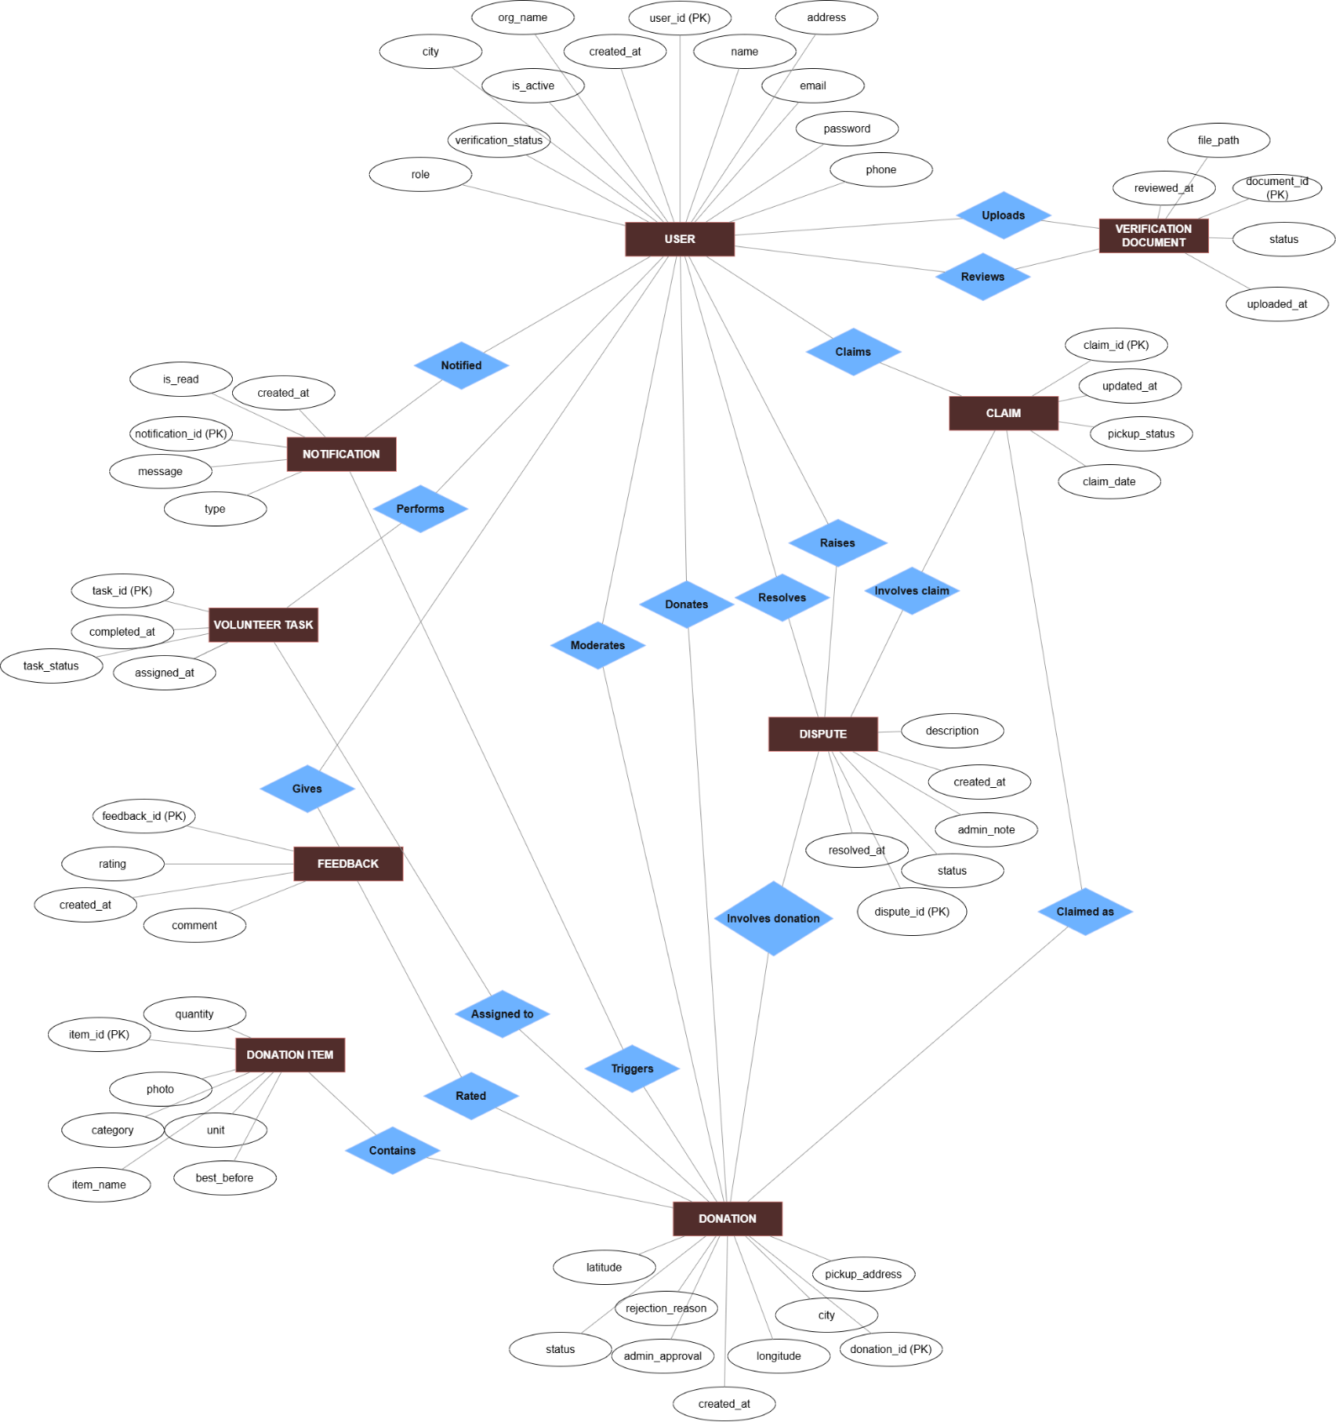

3. Sequence Diagrams
Figure 3.1:
User registers and logs. NGOs wait for admin approval. Admin verify documents.

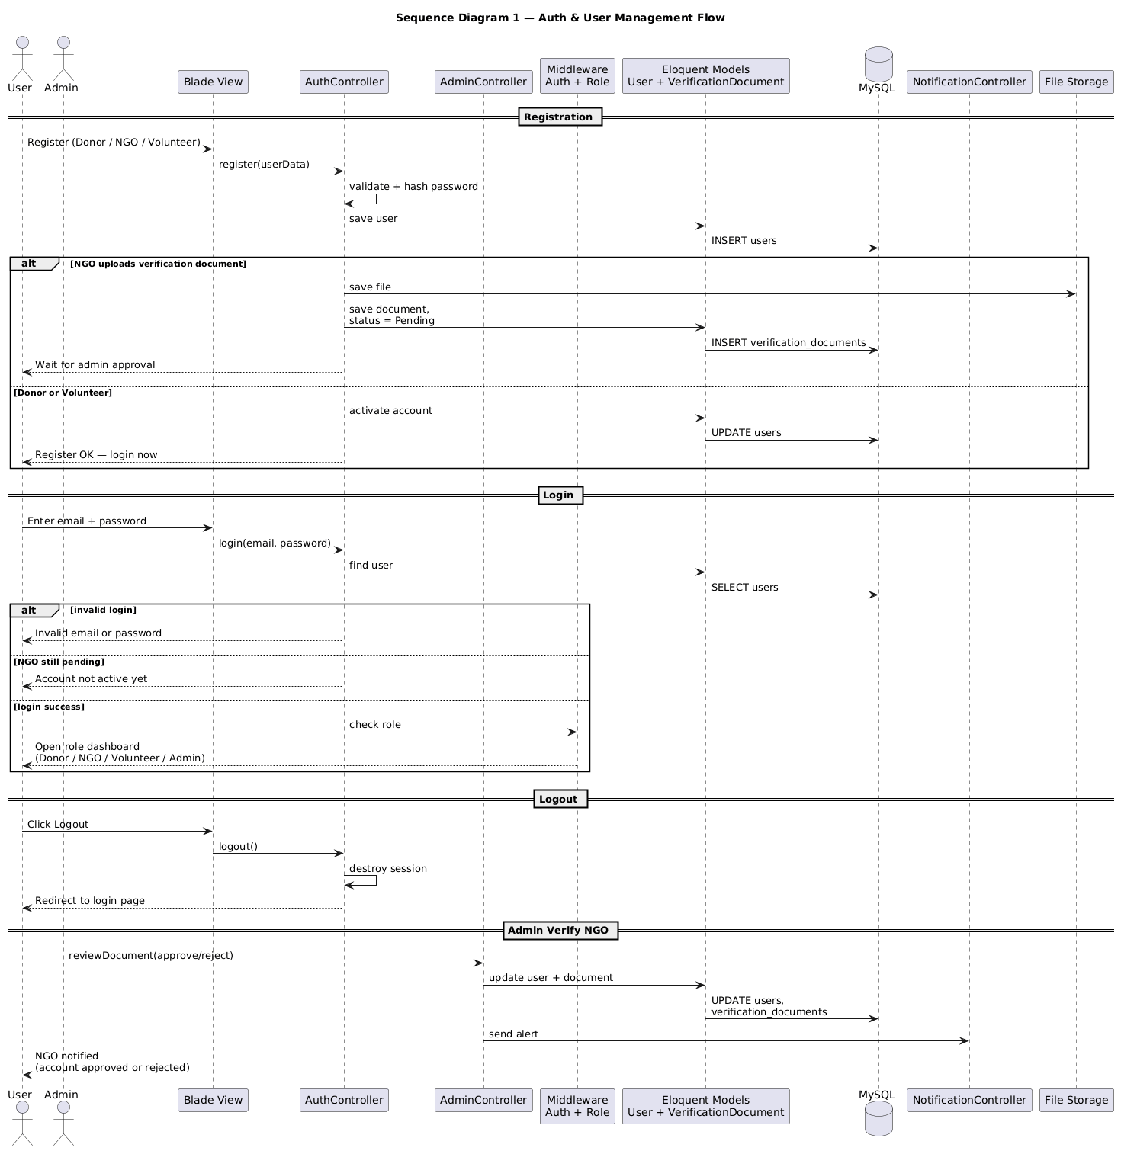

Figure 3.2:
Full donation path from post to claim to delivery.

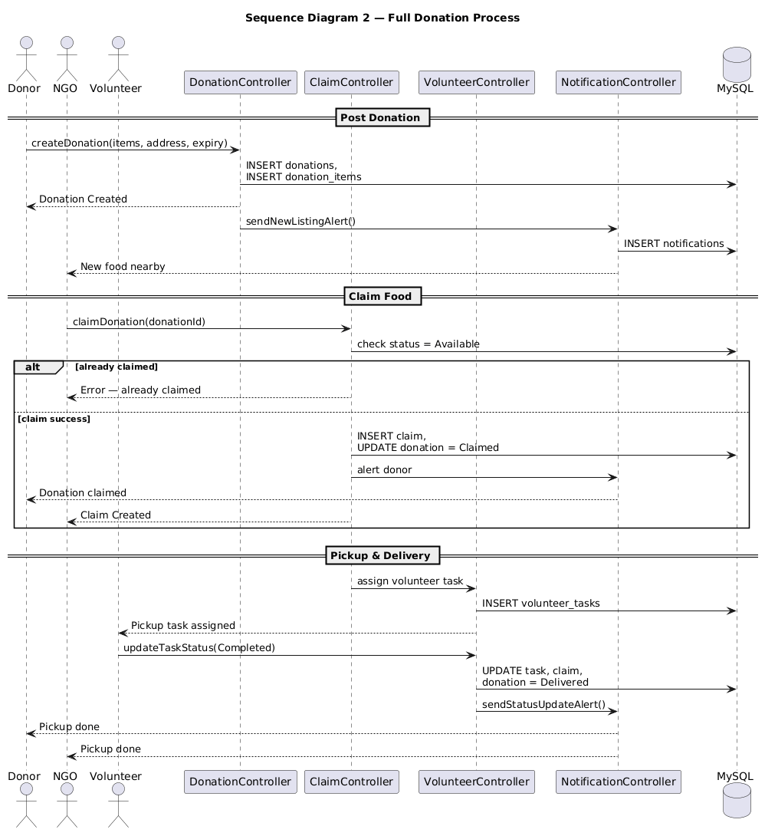

Figure 3.3:
Raise dispute; Admin resolves it and Notification alerts donor and NGO.

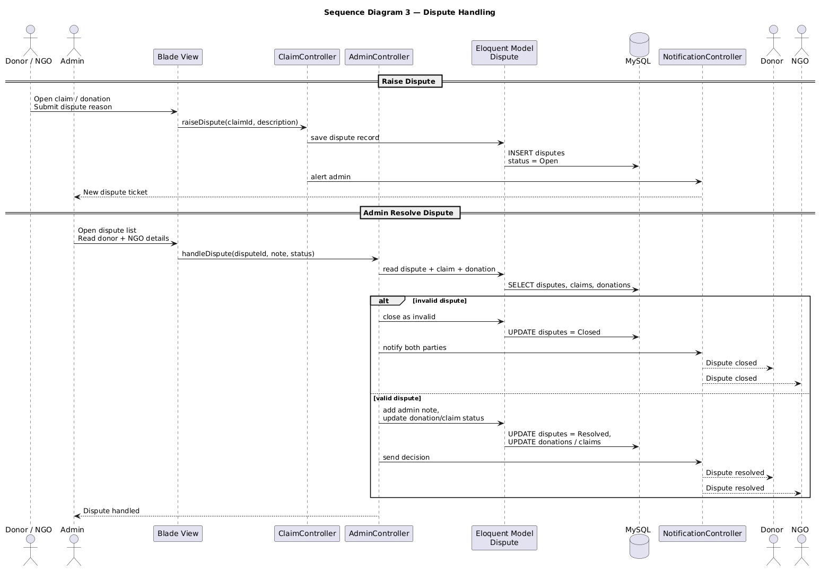

4. Architecture Design Diagram

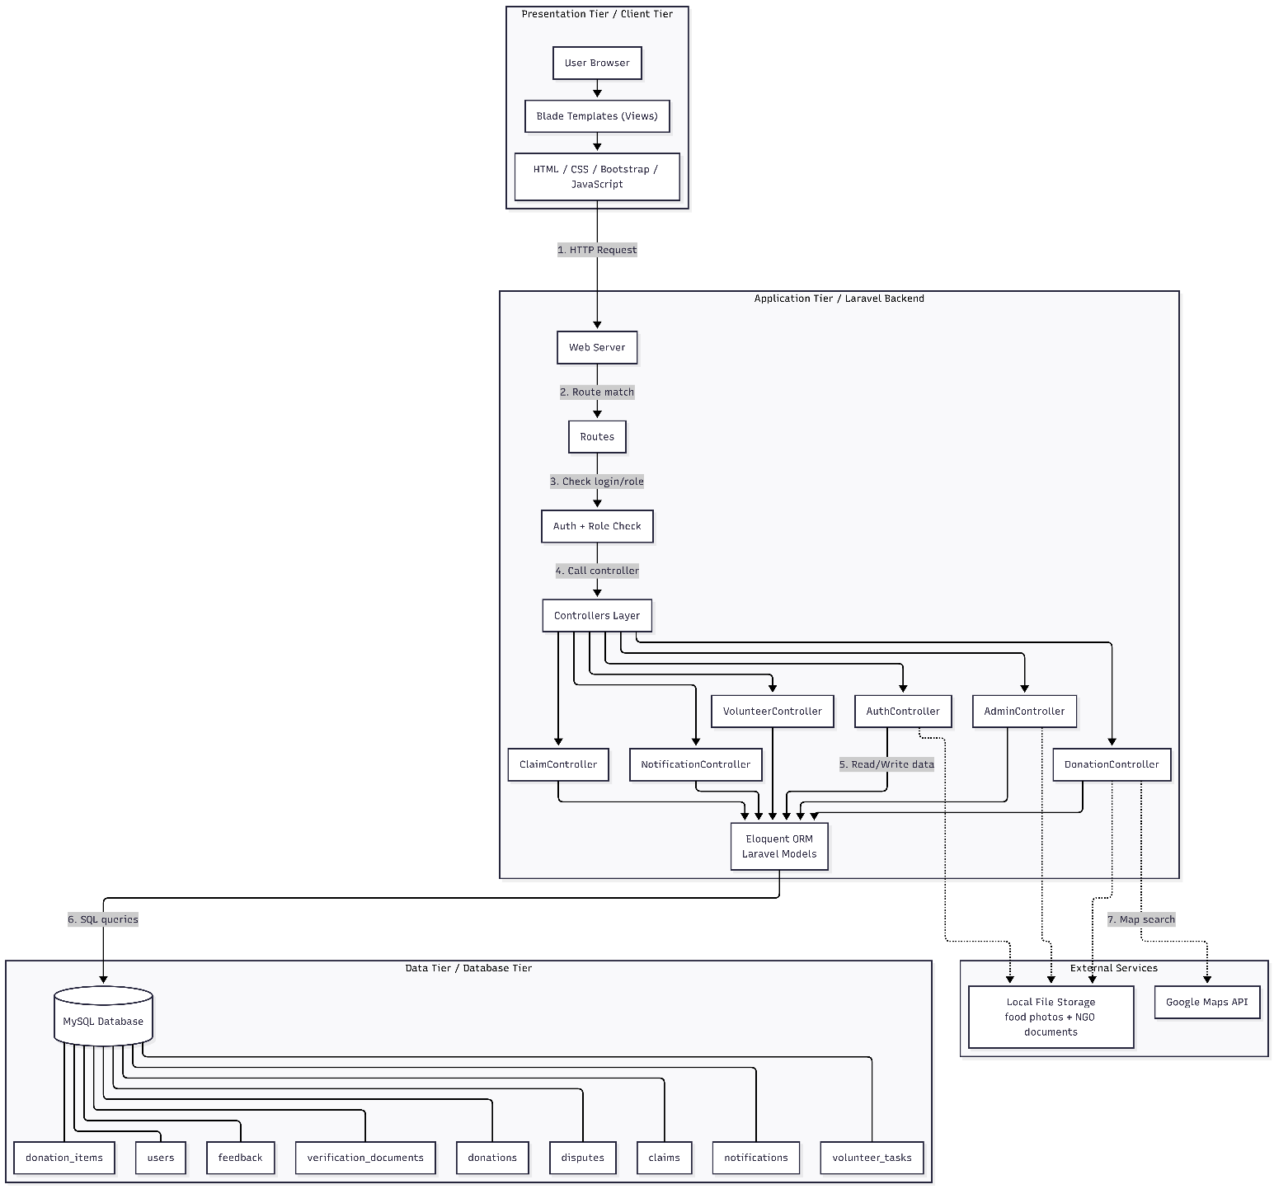

5. Class Diagram
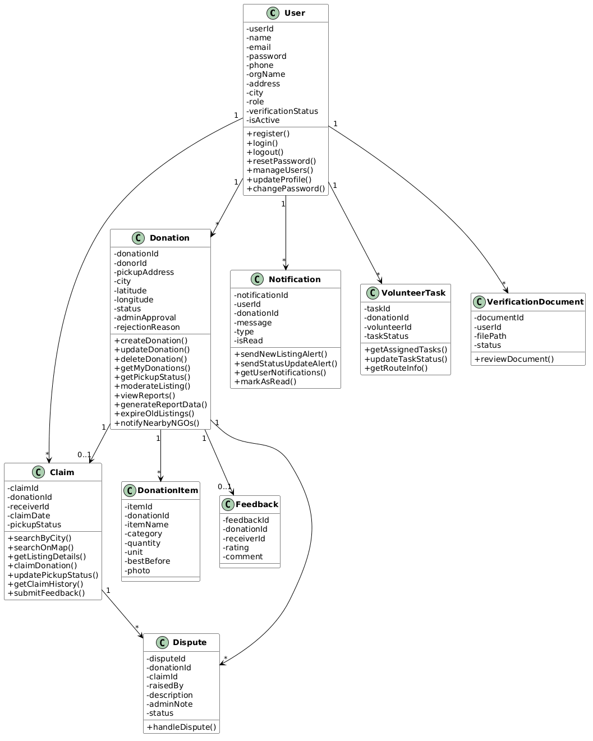

6. Database Design
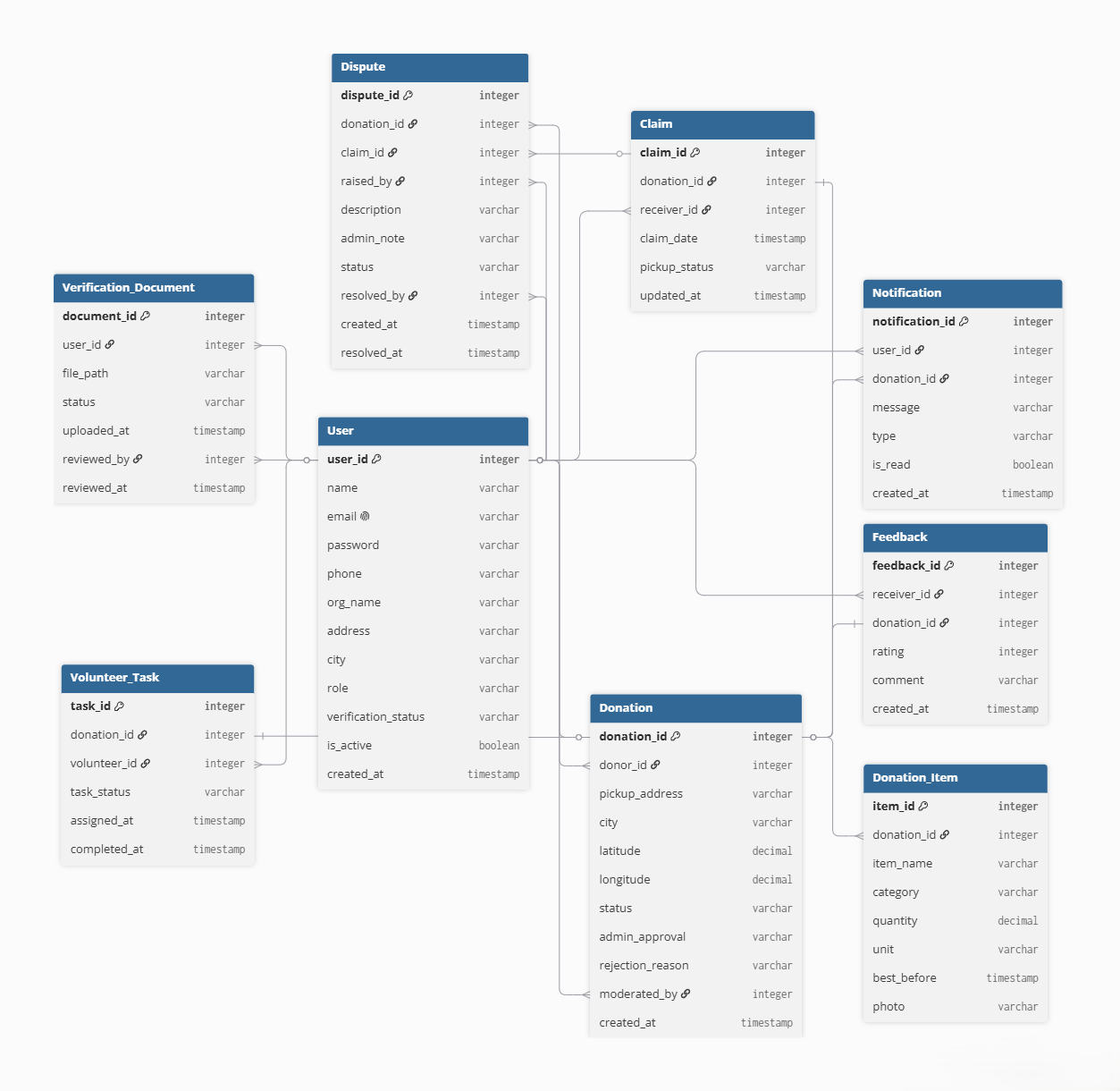

7. Interface Design
Combine:
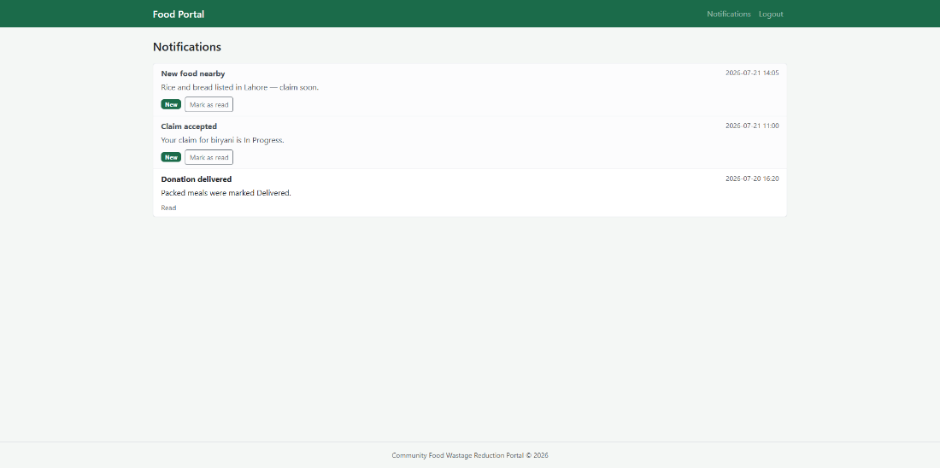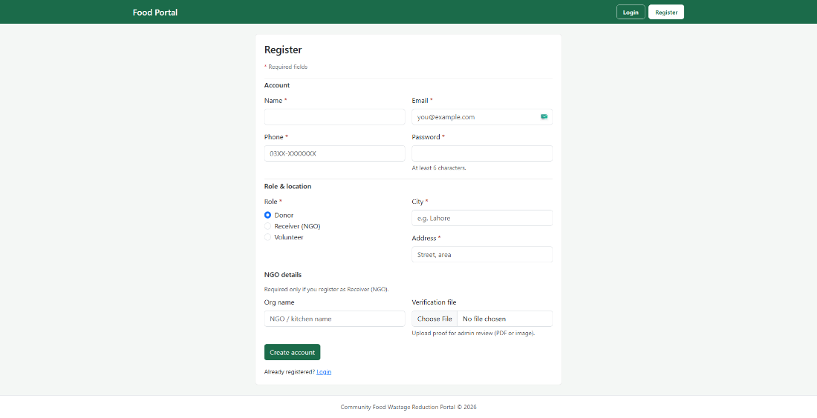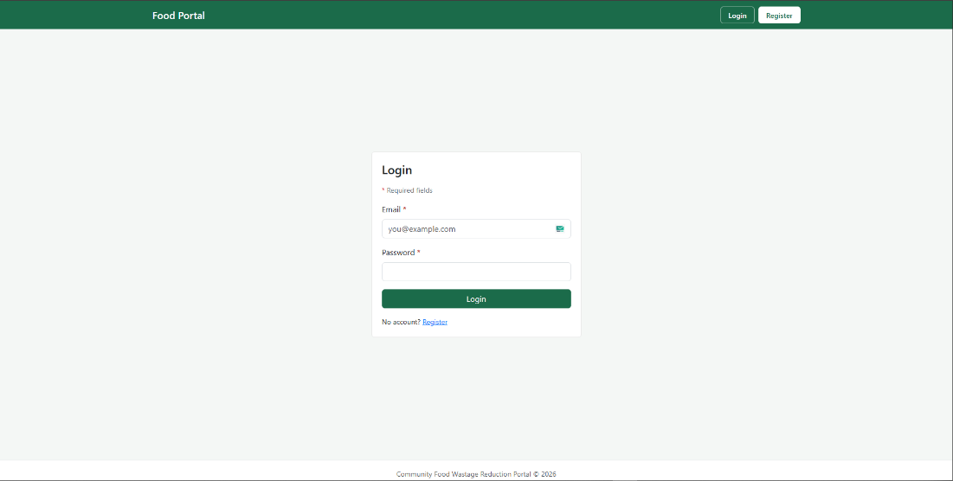

Admin Dashboard:
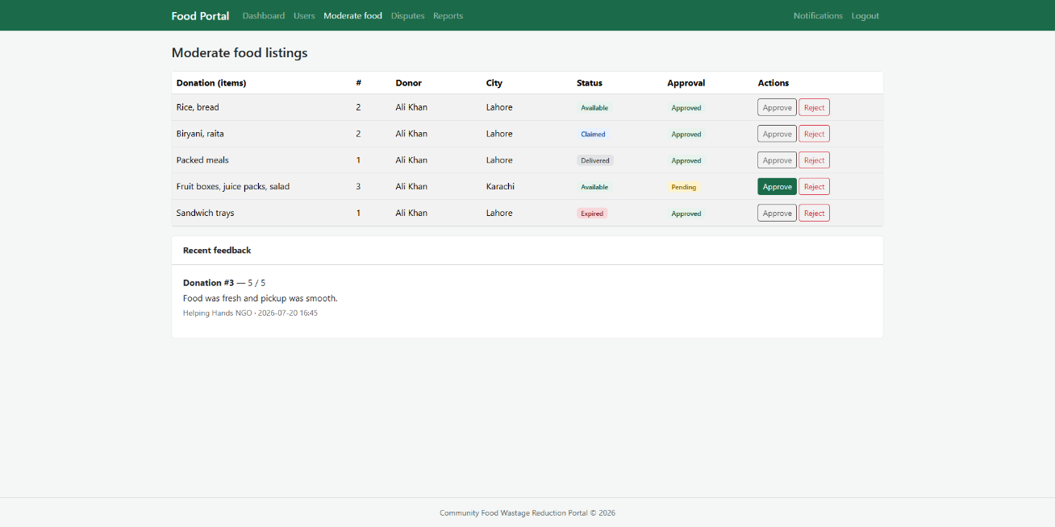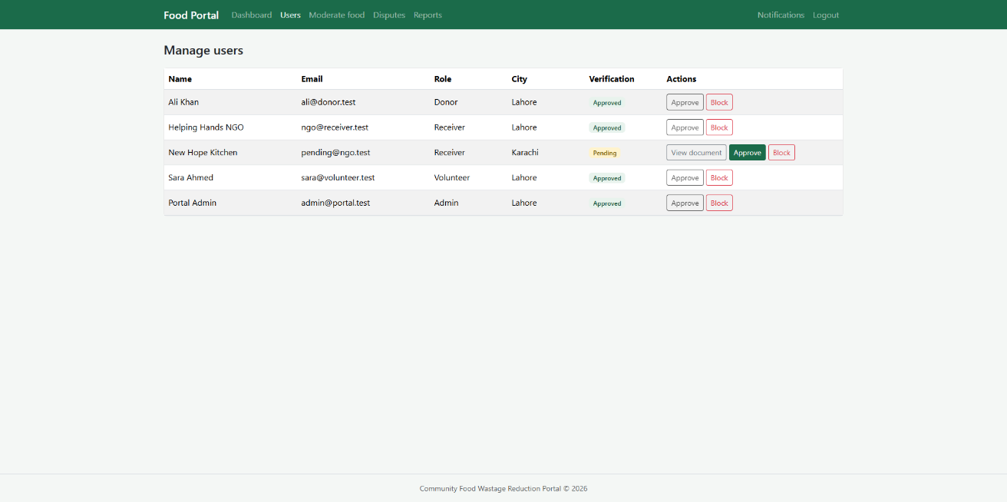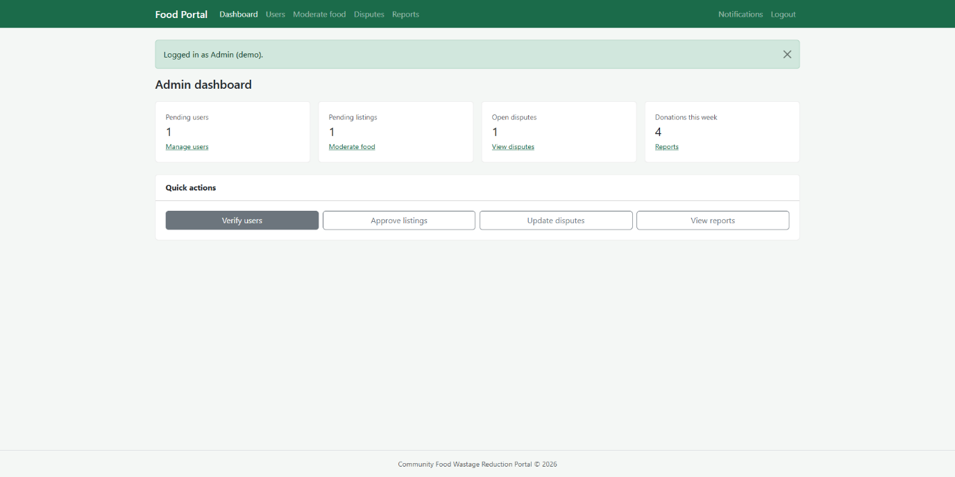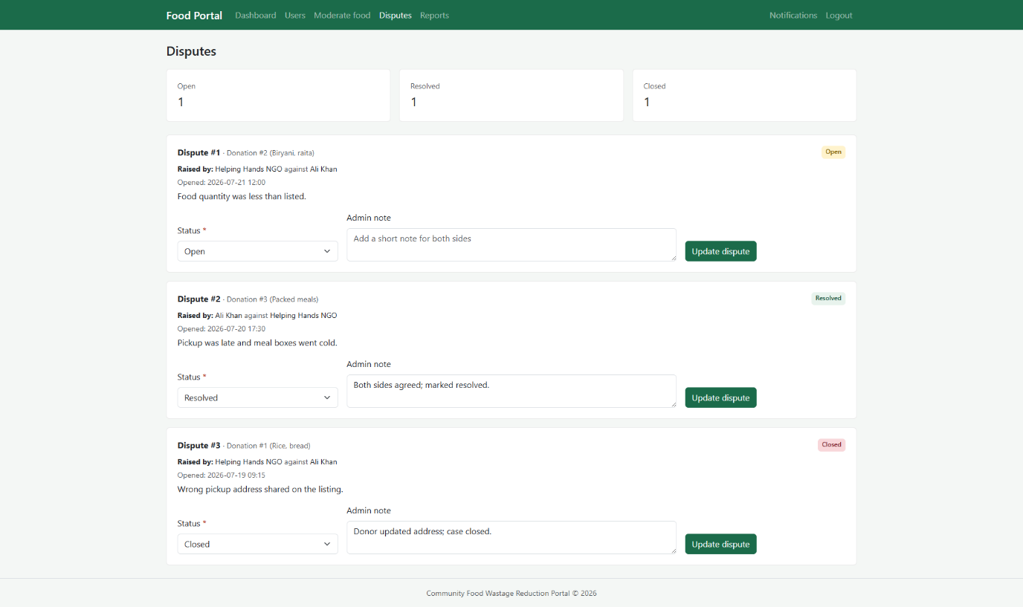

Doner Dashboard:
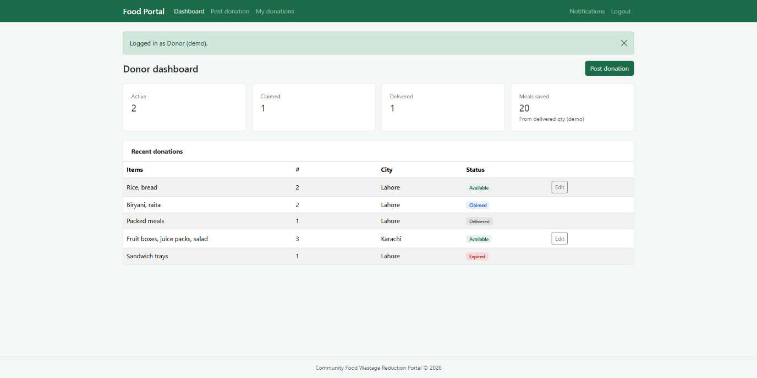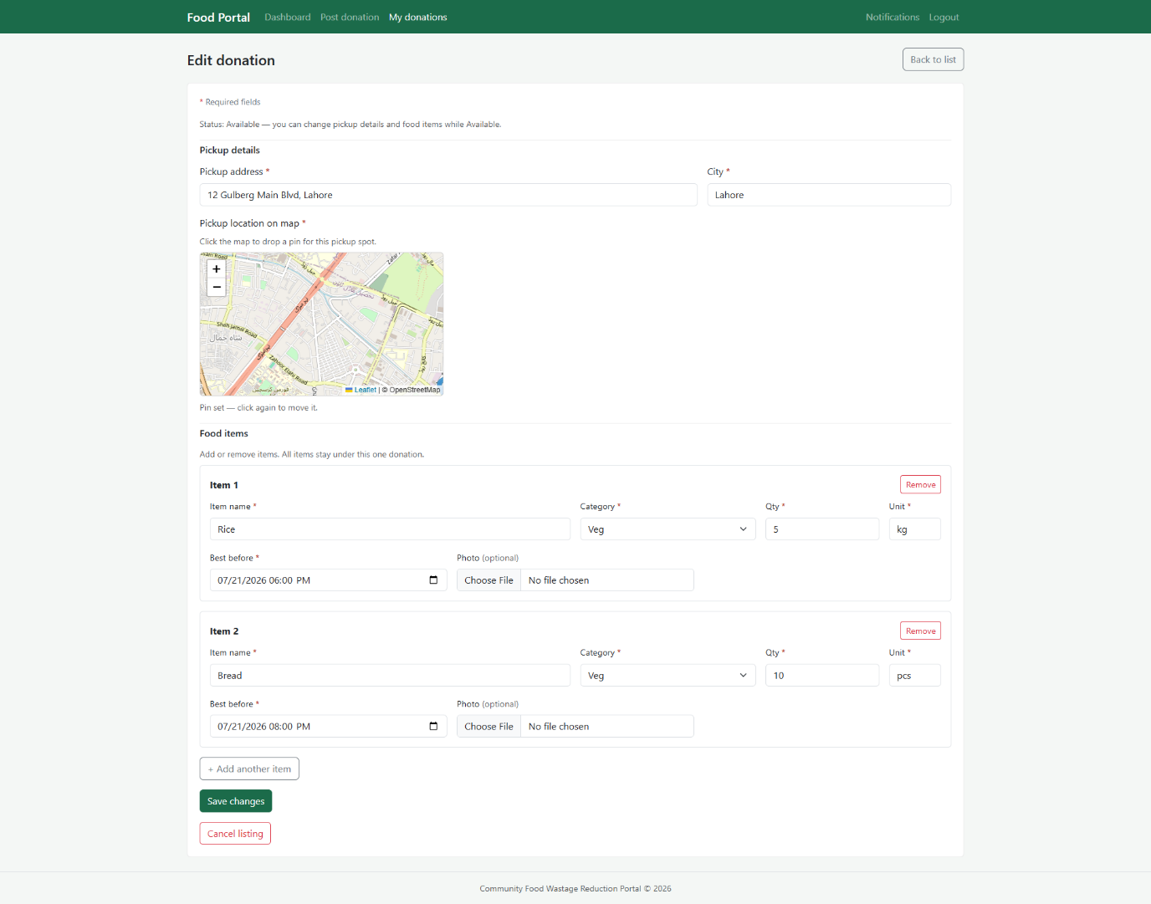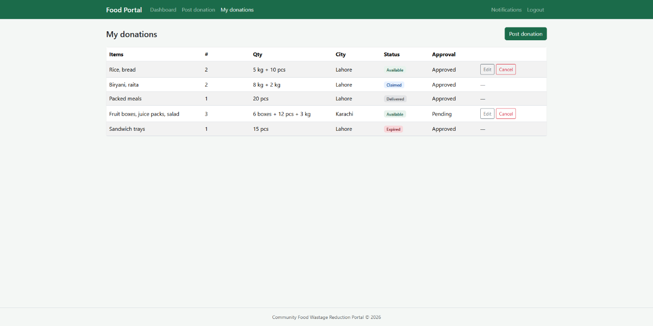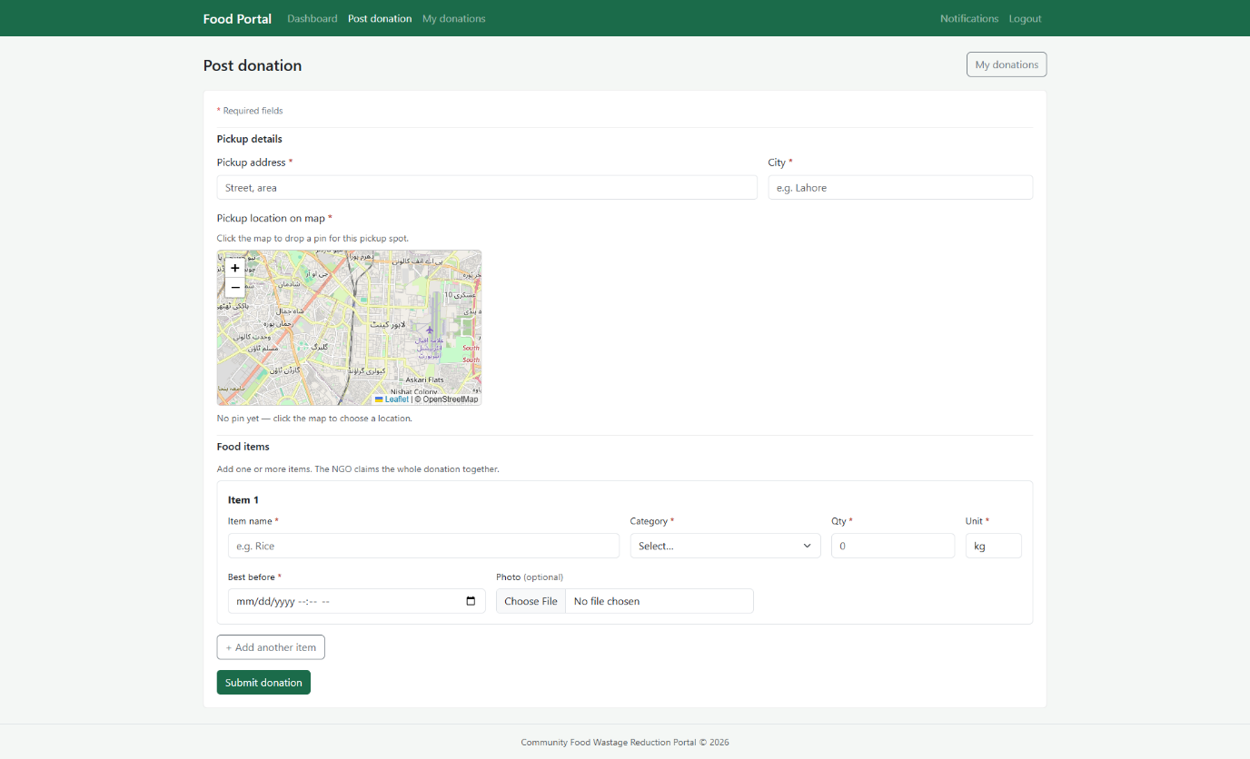

NGO Dashboard:
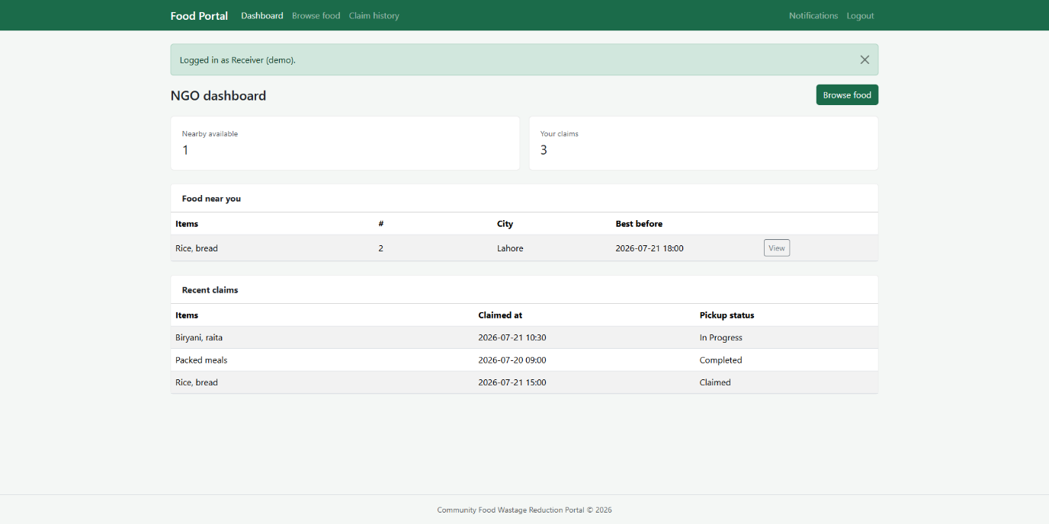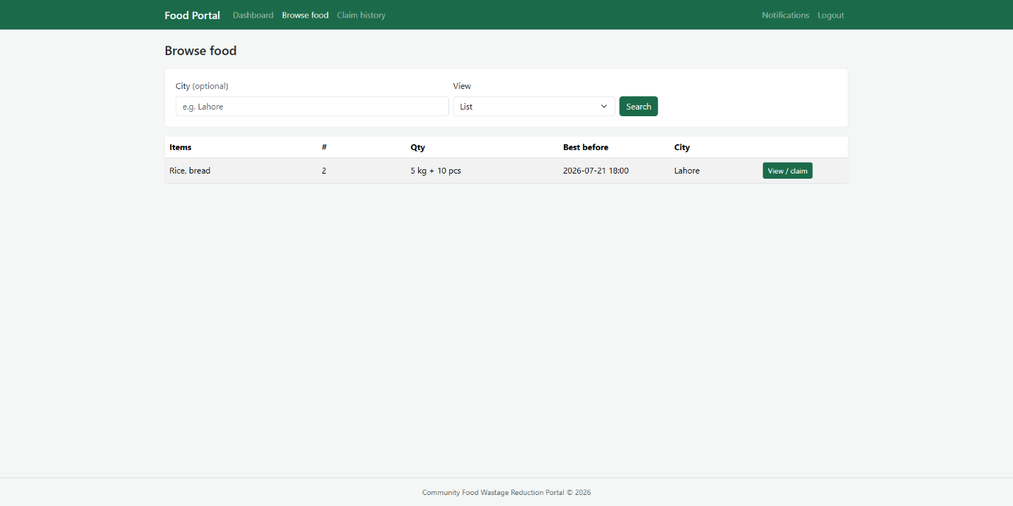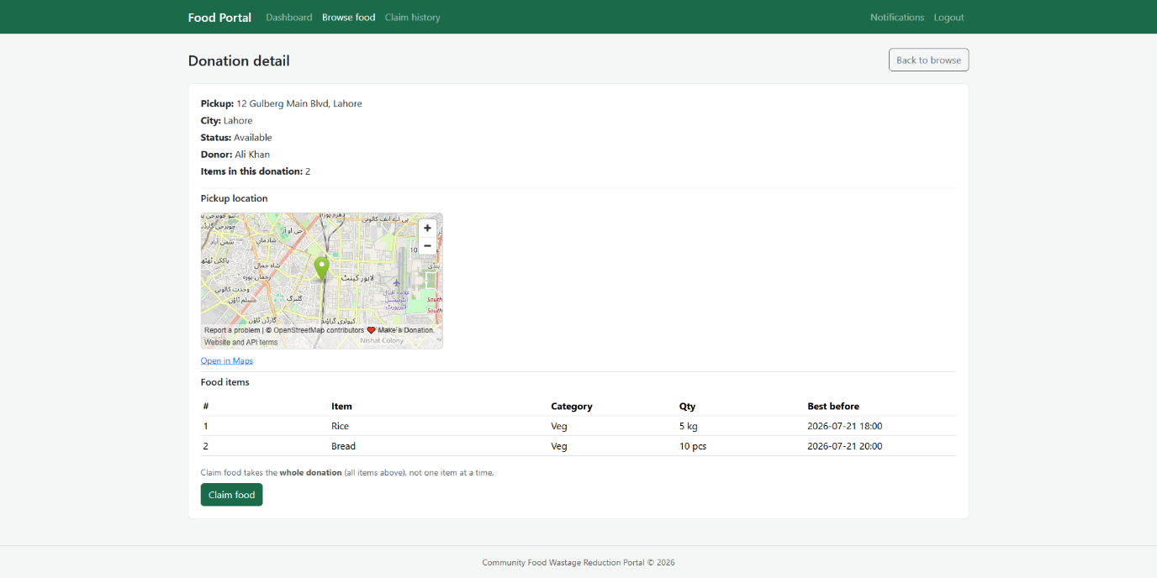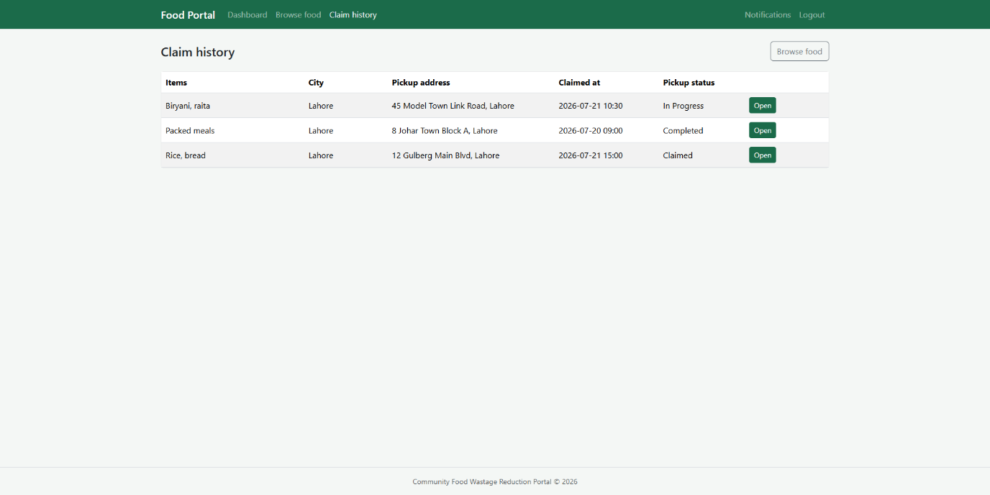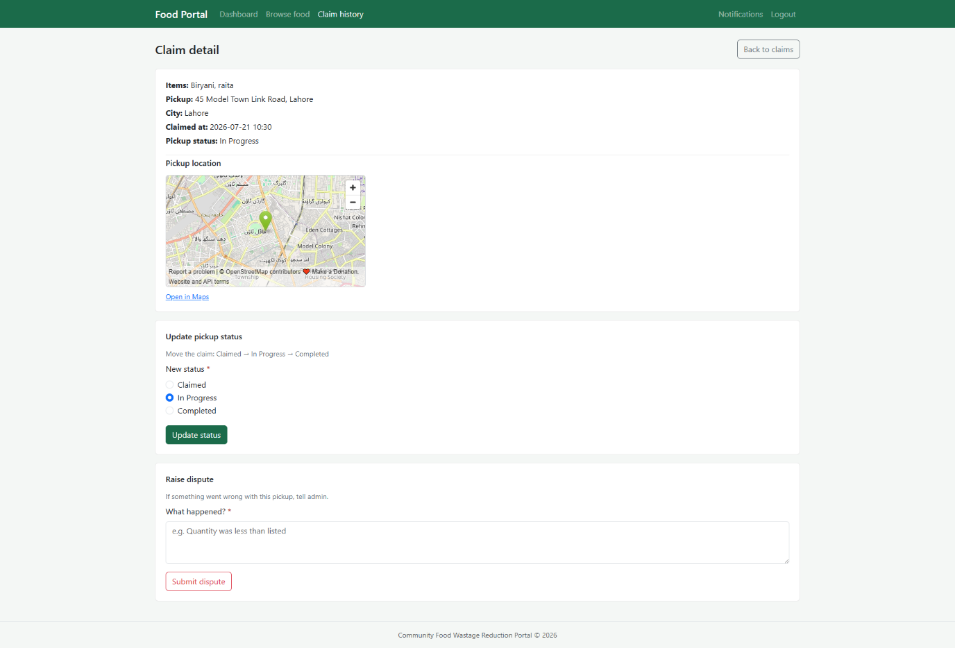

Volunteer Dashboard:
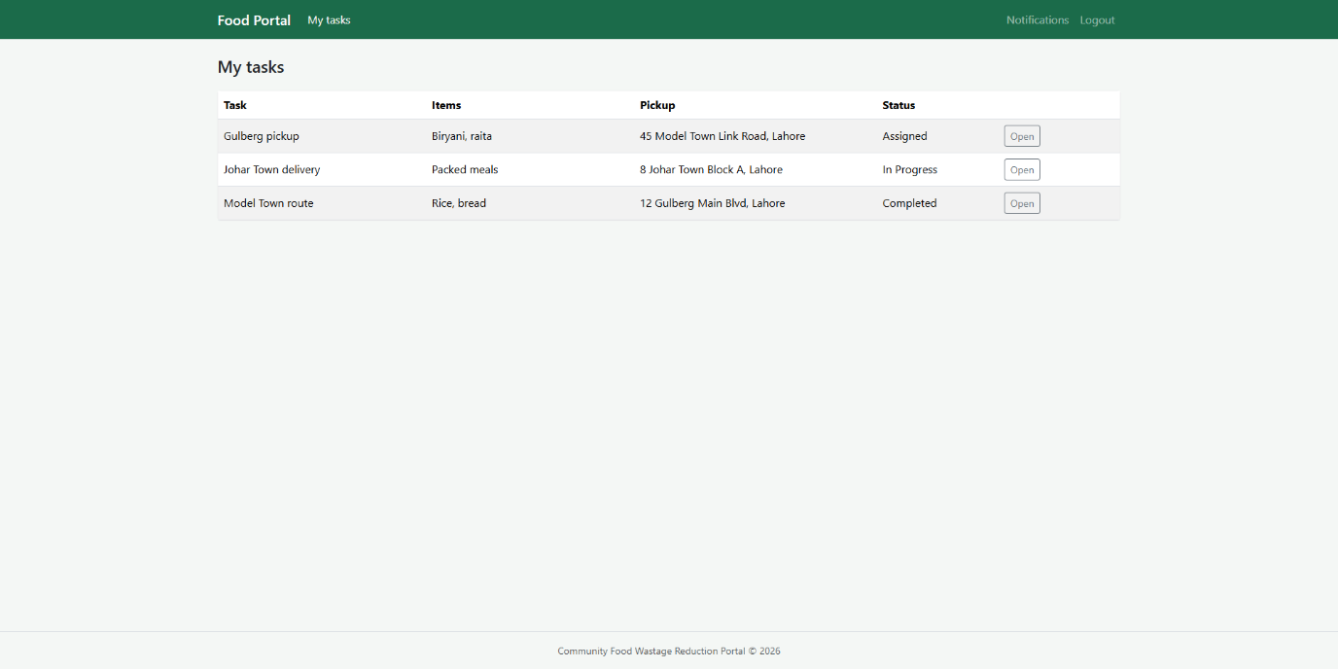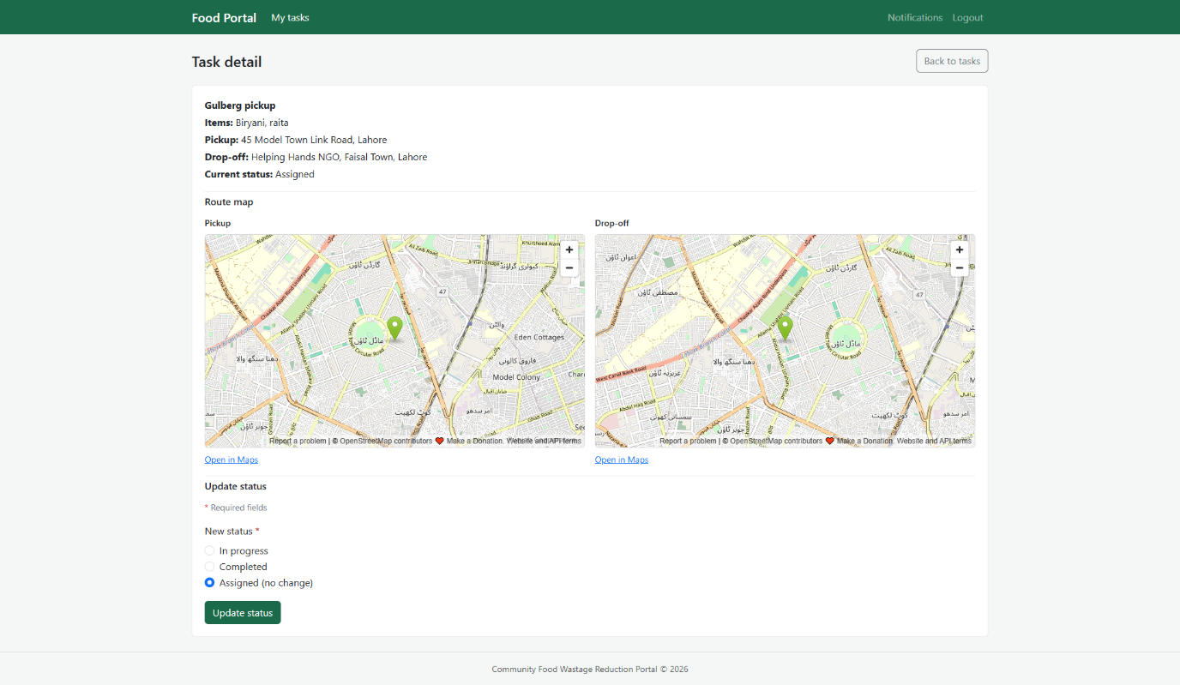

8. Test Cases

8.1 Purpose of Testing
These test cases check whether the portal works as planned in the SRS and design document. We will run them after development (and again before final submission) on the Laravel app using MySQL.
Each test has a Precondition, Steps, and Expected Result. Fill Actual Result and Pass/Fail when you test on your machine.
Test environment (planned):
- Browser: Chrome or Edge (latest)
- Server: Local Laravel (php artisan serve) or XAMPP
- Database: MySQL with sample users (Donor, NGO, Volunteer, Admin)

8.2 Test Case Summary
Module | Test IDs | Count
Auth & User Management | TC-01 to TC-06 | 6
Donation (Donor + Admin) | TC-07 to TC-11 | 5
Claim & Feedback (NGO) | TC-12 to TC-16 | 5
Volunteer | TC-17 to TC-18 | 2
Admin (Users, Disputes, Reports) | TC-19 to TC-22 | 4
Notifications | TC-23 to TC-24 | 2
Total | TC-01 to TC-24 | 24

8.3 Detailed Test Cases
A. Auth & User Management
Field | TC-01 | TC-02 | TC-03
Title | Donor registration | NGO registration with document | Valid user login
Precondition | Register page open; email not used before | Register page open | Donor account exists and is active
Steps | 1. Open /register  2. Select role Donor  3. Fill name, email, password, city  4. Submit | 1. Open /register  2. Select role NGO/Receiver  3. Fill form + upload verification file  4. Submit | 1. Open /login  2. Enter correct email and password  3. Submit
Expected Result | Account saved; user can log in; redirected or shown success message | Account saved with status Pending; message says wait for admin approval | User logged in; Donor dashboard opens
Actual Result
Pass/Fail

Field | TC-04 | TC-05 | TC-06
Title | Invalid login | Pending NGO blocked from login | User logout
Precondition | Login page open | NGO registered but admin not approved yet | User logged in as any role
Steps | 1. Open /login  2. Enter wrong email or password  3. Submit | 1. Open /login  2. Enter NGO pending credentials  3. Submit | 1. Click Logout from navbar  2. Try opening a dashboard URL directly
Expected Result | Error: invalid email or password; stay on login page | Error: account not active yet; no dashboard access | Session cleared; login page shown; dashboard blocked without login
Actual Result
Pass/Fail

B. Donation — Donor & Admin Moderation
Field | TC-07 | TC-08 | TC-09
Title | Post donation with multiple items | Admin approves listing | Admin rejects listing
Precondition | Logged in as Donor | Logged in as Admin; pending donation exists | Logged in as Admin; pending donation exists
Steps | 1. Open post donation form  2. Add 2+ food items (name, qty, expiry)  3. Enter pickup address/city  4. Submit | 1. Open admin donations/moderation  2. Select pending listing  3. Click Approve | 1. Open admin donations  2. Select pending listing  3. Click Reject + enter reason
Expected Result | Donation + donation_items saved; status Pending or Available; success message | Listing approved; visible to NGOs in browse/search | Listing rejected; hidden from NGO search; donor can see rejection reason
Actual Result
Pass/Fail

Field | TC-10 | TC-11
Title | Donor edits own donation | Donor cancels available donation
Precondition | Logged in as Donor; owns an Available listing | Logged in as Donor; owns Available listing not yet claimed
Steps | 1. Open My Donations  2. Edit listing (quantity or address)  3. Save | 1. Open My Donations  2. Cancel/delete listing  3. Confirm
Expected Result | Updated data saved; listing shows new values | Listing status Cancelled or removed; no longer in NGO search
Actual Result
Pass/Fail

C. Claim, Search & Feedback — NGO
Field | TC-12 | TC-13 | TC-14
Title | Search food by city | Claim available donation | Claim already-claimed donation
Precondition | Logged in as NGO; approved listings exist in DB | Logged in as NGO; donation status Available | Logged in as NGO; donation already Claimed by another NGO
Steps | 1. Open browse food  2. Enter city name  3. Search | 1. Open donation details  2. Click Claim food | 1. Open same donation (or refresh)  2. Click Claim food
Expected Result | Only listings in that city shown | Claim record created; donation status Claimed; donor notified | Error message; claim not created; status unchanged
Actual Result
Pass/Fail

Field | TC-15 | TC-16
Title | Update pickup status | Submit feedback after delivery
Precondition | Logged in as NGO; active claim exists | Logged in as NGO; claim status Delivered/Completed
Steps | 1. Open claim detail  2. Change status (e.g. In Progress → Completed)  3. Save | 1. Open completed claim  2. Select rating + short comment  3. Submit feedback
Expected Result | Claim and donation status updated in DB; donor notified | Feedback saved; linked to donation and NGO
Actual Result
Pass/Fail

D. Volunteer
Field | TC-17 | TC-18
Title | View assigned pickup task | Mark task completed
Precondition | Logged in as Volunteer; task assigned for a claim | Logged in as Volunteer; task status In Progress
Steps | 1. Open volunteer tasks list  2. Open one task detail | 1. Open task detail  2. Set status to Completed  3. Save
Expected Result | Task shows address, donation info, current status | Task, claim, and donation updated to completed/delivered; notifications sent
Actual Result
Pass/Fail

E. Admin — Users, Disputes, Reports
Field | TC-19 | TC-20 | TC-21
Title | Admin verifies NGO user | Admin resolves valid dispute | Admin closes invalid dispute
Precondition | Logged in as Admin; pending NGO + document in queue | Open dispute exists with donor + NGO details | Open dispute with weak/no evidence
Steps | 1. Open admin users  2. Review NGO document  3. Approve account | 1. Open admin disputes  2. Read details  3. Add admin note + set Resolved | 1. Open dispute  2. Add note + set Closed
Expected Result | NGO verification_status Approved; NGO can log in | Dispute status Resolved; donation/claim updated if needed; both parties notified | Dispute Closed; parties notified
Actual Result
Pass/Fail

Field | TC-22
Title | Admin views reports
Precondition | Logged in as Admin; donations and claims exist in DB
Steps | 1. Open admin reports  2. View totals (donations, claims, deliveries)  3. Optional: filter by city
Expected Result | Correct counts from database; city filter works
Actual Result
Pass/Fail

F. Notifications
Field | TC-23 | TC-24
Title | View user notifications | Mark notification as read
Precondition | User logged in; unread notifications exist (e.g. after new listing or claim) | Logged in; unread notification on list
Steps | 1. Open notifications page  2. Check list content | 1. Open notifications  2. Click mark as read on one item
Expected Result | Notifications shown with correct message and type | That notification marked read; stays in history
Actual Result
Pass/Fail

